

Month 20XX
Project name
Environmental Assessment,
DOI-BLM-State-Office ePlanning ID-Fiscal Year-NEPA Number-EA
Applicant: If Applicable
Case or Lease Number: If Applicable

  - Field/District Office
  - Address
  - City, State, Zip
  - Project Name

Table of Contents
1.0 Introduction 1
2.0 Alternatives 2
3.0 Affected Environment and Environmental Consequences 3
4.0 Consultation and Coordination 7
5.0 List of Appendices 8
Appendix A: List of Preparers 9
Appendix B: Acronyms and Abbreviations 10
Appendix C: List of References 12
Appendix D: Maps 13
Appendix E: Figures 14
Appendix F: Tables (over one page) 15

1.0 Introduction

1.1 Summary of Proposed Project
Briefly discuss the project/proposal, location, applicant or proponent (if applicable) and their purpose and need for applying for the project. Include map here or reference one elsewhere in the document. Be sure to present, up front, the problem, supporting evidence, and then a short description of the proposed action. The full description of the Proposed Action will be in Chapter 2 so include a short description here!

1.2 Purpose and Need
Describe the BLM’s purpose and need. …for example: to respond to an application from a proponent for ROW or permit renewal application. You do not have to separate out the purpose and need.

1.3 Decision to be Made
This is BLM’s decision to be made – again short one or two sentences is all that should be needed. If we have cooperators using this NEPA, you can explain their decision (or need) here as well to clarify roles.

1.4 Land Use Plan Conformance
Reference the specific part of the RMP in which the proposal is in conformance. If no specific reference, use a statement like: The proposed action is in conformance with the xx RMP. Even though the proposed action is not specifically mentioned, it is consistent with the decision(s) [or objective(s)] listed below.
If you’re doing a plan amendment, discuss it here and not in purpose and need because there may be an alternative to meet the P&N without an amendment.

1.5 Relationship to Statutes, Regulations, Other NEPA Documents
Identify documents you intend to tier to, or other key reference documents. If for some reason the project needs a summary of the laws, regulations, policies, program guidance, and local permitting requirements that are directly relevant to the proposed action need to be included, put them here. However, for a simple project, especially with effective tiering or incorporation by reference, this section may not need any laws, regulations, etc. summarized in it. Do not put in an exhaustive list of all applicable laws.

1.6 Issues Identified for Analysis
Ask yourself “why is this issue/resource impacted by the proposed action”. Refer to the criteria in the BLM NEPA Handbook section that defines issues (Section 6.4, page 40). Only the issues discussed here should be discussed in the Affected Environment/Environmental Effects. Entire resources (e.g., wildlife) are not resource issues.

Issue 1 – Example: How would grazing operations impact Sage Grouse

Issue 2 – IBID

Issue 3 – IBID

1.7 Issues Identified but Eliminated from Further Analysis (If Applicable)
This should be just a short summary paragraph of what was brought up but not considered. A more detailed write-up of issues that aren’t analyzed can be documented in the project file. Do make sure to note which issues eliminated were brought up by the public, as opposed to those eliminated during internal scoping. Resources that aren’t present in the project/action area or that won’t be affected by the proposed action(s) should not be analyzed.

2.0 Alternatives

2.1 Alternative 1 - No Action Alternative
List this alternative first since it provides a baseline for comparison of environmental effects and demonstrates what would happen if we did not do the project. For internally-generated actions, the No Action Alternative is to not take the action and to continue the existing management. For externally-generated proposals or applications, the No Action Alternative is generally to reject the proposal or deny the application (except for grazing).

2.2 Alternative 2 - Proposed Action Alternative
Include Who, What, Where, How and When, as well as any Design Features. Create an appendix if the Design Features are longer than ½ to 1 page.

2.3 Alternative 3 – If Applicable
Alternatives must be developed to address unresolved issues associated with the Proposed Action. Additional alternatives (e.g., Alternatives C and D) may be necessary to ensure an adequate range of viable options is being analyzed.
Design features incorporated into the Proposed Action can be adequate for resolving conflicts or issues. In such cases, additional alternatives—beyond the Proposed Action and no action alternatives—would not be necessary (and this subsection can be deleted).
Refer to section 6.6 of the BLM NEPA Handbook (H-1709-1) for information on developing alternatives.

2.4 Alternative 4 – If Applicable
Alternatives must be developed to address unresolved issues associated with the Proposed Action. Additional alternatives (e.g., Alternatives C and D) may be necessary to ensure an adequate range of viable options is being analyzed.
Design features incorporated into the Proposed Action can be adequate for resolving conflicts or issues. In such cases, additional alternatives—beyond the Proposed Action and no action alternatives—would not be necessary (and this subsection can be deleted).
Refer to section 6.6 of the BLM NEPA Handbook (H-1709-1) for information on developing alternatives

2.5 Alternatives Considered but not Analyzed in Detail (If Applicable)
What alternatives (or portions of alternatives) were considered, such as different routes for a pipeline? Document the process here – that we considered a variety of options.
Table 1: Comparison of Alternatives
Issues/Indicators | Alternative 1—No Action | Alternative 2—Proposed Action | Alternative 3 | Alternative 4
Issues/Indicator 1 | No effect | Mining may have minimal impacts to local water body/stream | Alternative mining location would not have impacts to local water body/stream | Alternative mining location would have less impacts to local water body/stream than Alternative 2
Issues/Indicator 2
Issues/Indicator 3

3.0 Affected Environment and Environmental Consequences
This chapter describes (1) the affected environment, specifically the existing or baseline conditions relevant to each issue identified in Table 1, followed by (2) a description of the direct, indirect, and cumulative impacts projected to result from each alternative.
Briefly describe the environmental setting of the project area and any other general information that helps the reader understand the area. It’s a good idea to include or reference a map (included in the appendix). Limit discussion below to resources/issues that are relevant.
Also, included in Appendix B is a table of the resources one may or may not encounter in the analysis area. Resources that are not impacted (NI) or not present (NP) are not analyzed. Resources that are present and impacted are designated with a (PI).
For resources present but not impacted, provide rationale next to the (NI) determination as to why the IDT believes the present resource will not be impacted. Do not put in a lengthy paragraph; just a short summary.

3.1 Resource Issue 1

3.1.1 Affected Environment
Use Resource Indicators identified in Chapter 1 (if relevant) to quantify the affected environment (e.g., describe the current or existing numbers, acres, miles, AUMs, dollars, etc.). Not all resources/impacts can be measured quantitatively so make sure to use qualitative information where necessary and appropriate. Summarize past and present actions in this section; reasonably foreseeable future actions belong under Cumulative Effects.
Offices are strongly encouraged to keep the resource issue analyses to 1-2 pages; do not create an encyclopedic summary of the issue in question.

3.1.2 Environmental Impacts—No Action Alternative
Discuss methodology and assumptions relevant to your analysis. If a lengthy RFD or model is used, it can be in the appendix and results discussed here. Avoid subjective terms such as good or bad. Direct effects are those which are caused by the action and occur at the same time and place. Indirect effects are reasonably predictable and caused later in time or farther removed in distance from the action.

3.1.3 Environmental Impacts—Proposed Action
Describe the effect related to the issue in enough detail to inform the decision maker and provide for a reasoned choice among the options. Provide, to the extent information is available, a quantitative analysis that describes the direct, indirect, and cumulative impacts of the alternative on the impact indicator specific to the issue.
This general outline may be followed for the impacts analysis:
- Indicate the project element (change agent) causing the impact to the resource.

- Quantify the impact using the appropriate impact indicator.

- Provide a qualitative description of the impact, including appropriate linkages, put in the context established under the affected environment.

- Provide an analytical conclusion—“so what?”—that interprets the results.
It is not necessary to specify whether an impact is considered direct or indirect. For the cumulative impact analysis, use the same impact indicator and analysis methodology that is used for direct and indirect impacts for each issue. If there would be no cumulative impact, state that, and provide supporting rationale and analysis.
As stated above, offices are strongly encouraged to keep the resource issue analyses to 1-2 pages; do not create an encyclopedic summary of the issue in question.

3.1.4 Environmental Impacts—Alternative 3 (if applicable)
Describe the impacts from this alternative at the same level of detail as under the Proposed Action—using the same impact indicator—in order to provide a comparative analysis and a basis for a reasoned choice among the options.

3.1.5 Environmental Impacts—Alternative 4 (if applicable)
Describe the impacts from this alternative at the same level of detail as under the Proposed Action—using the same impact indicator—in order to provide a comparative analysis and a basis for a reasoned choice among the options.

3.1.6 Cumulative Effects
Cumulative impacts consider the relevant past, present, and reasonably foreseeable future actions (past and present actions can be summarized in the Affected Environment; only reasonably foreseeable future actions need to be in here). Each issue generally has its own geographic scope and temporal scopes, but these can be concurrent among some issues. The geographic scope is based on the resource’s natural boundaries. The temporal scope is based on the duration of the effects of the alternative, not the timeframe of the actions taken within the alternative.
Within the geographic scope and timeframe for analysis, include a description of any other reasonably foreseeable future actions (whether on BLM-administered lands or other lands). Reasonably foreseeable future actions are those for which there are existing decisions, funding, formal proposals, or which are highly probable, based on known opportunities or trends.

3.1.7 Mitigation and Residual Impacts
Mitigation includes specific means, measures or practices (BMPs) that would reduce or eliminate effects of the proposed action or alternatives added to the project after the project is developed. If measures are part of the alternatives in Chapter 2, then the measures are called “design features” and do not need to be included in this section. This section is necessary for all residual effects, and it is to the discretion of the authorized officer to decide whether they ought to be applied in the final authorization.

3.2 Issue 2

3.2.1 Affected Environment

3.2.2 Environmental Impacts—No Action Alternative

3.2.3 Environmental Impacts—Proposed Action

3.2.4 Environmental Impacts—Alternative 3 (if applicable)

3.2.5 Environmental Impacts—Alternative 4 (if applicable)

3.2.6 Cumulative Effects

3.2.7 Mitigation and Residual Impacts

3.3 Issue 3
3.3.1 Affected Environment
3.3.2 Environmental Impacts—No Action Alternative
3.3.3 Environmental Impacts—Proposed Action
3.3.4 Environmental Impacts—Alternative 3 (if applicable)
3.3.5 Environmental Impacts—Alternative 4 (if applicable)
3.3.6 Cumulative Effects
3.3.7 Mitigation and Residual Impacts

4.0 Consultation and Coordination

4.1 Summary of Consultation and Coordination
Identify the persons, groups, agencies, or other parties consulted or coordinated with during the preparation of this analysis. Then summarize the conclusions or findings of the consultation or coordination effort. This could be presented in a table when more than one party was consulted.

4.2 Summary of Public Participation (If Applicable)
Briefly describe the opportunities for public involvement provided during the preparation of the EA, including ePlanning postings, letters, public meeting, and other outreach efforts. Reference section 1.4 of this EA, which describe public scoping efforts, so that information is not repeated.
If the EA was released to the public for review and comment, summarize the details about this opportunity, including dates, methods, and other pertinent information.

4.2.1 Public Comments Analysis (If Applicable)
Include this subsection here if the discussion is less than a page or two. But if the discussion is more than a couple of pages, include this discussion in an appendix, and provide a reference to the appendix under section 4.2.
The office may also elect to respond to comments in the Decision Record, rather than the EA (BLM NEPA Handbook, page 65). That would save on additional page space in this section.
Identify and respond to all substantive comments on the EA submitted during the public review and comment period. This could be presented in a table inserted here or in an appendix.
Present the substantive comments or a summary of the comments along with a response to each. The response should be either (1) an indication as to how the EA is changed, in which case specify where the change is made in the document, or (2) an explanation as to why the comment did not warrant a change to the document.

5.0 List of Appendices

Appendix A—List of Preparers

Appendix B—Table of Issues Considered

Appendix C—Acronyms and Abbreviations

Appendix D—List of References

Appendix E—Figures

List of Figures

Appendix F—Maps

List of Maps

Appendix G—Tables

List of Tables

Appendix H—Optional Appendix as needed

Appendix A: List of Preparers
Name | Title | Resource Area

Appendix B: Table of Issues Considered
Table B-1: List of Issues Considered
This table provides an exhaustive list of issues, resources and uses for which issues may arise. Each office should carefully modify this table to include issues, resources or uses that are “present” within the administrative boundary of the unit.
If any issue, resource or use topic does not have a subject matter expert on the IDT (for example, it is common for an IDT to lack a scarce skill such as socioeconomics or air quality), it is the role of the project lead to give that resource careful consideration. Project leads are encouraged to consult with state, zoned, or national office subject matter experts if there is any uncertainty on whether a resource or use is present and/or affected.
Determination* | Issue | Rationale for Determination
 | Air Quality
 | Areas of Critical Environmental Concern
 | Cultural Resources
 | Environmental Justice
 | Farmlands (Prime or Unique)
 | Fire Management
 | Fish Habitat
 | Floodplains
 | Forests and Rangelands
 | Forestry Resources and Woodland Products
 | Human health and safety concerns
 | Invasive, Non-native Species
 | Lands and Realty
 | Lands with Wilderness Characteristics
 | Livestock Grazing Management
 | Migratory birds and wildlife
 | Native American Religious Concerns
 | Noise Resources
 | Paleontological Resources
 | Recreation Resources
 | Sage Grouse Habitat
 | Socioeconomics
 | Soils
 | Threatened, Endangered or Candidate Plant or Animal Species
 | Vegetation
 | Visual Resources
 | Wastes, Hazardous or Solid
 | Water
 | Wetlands/Riparian Zones
 | Wild Horses and Burros
 | Wild and Scenic Rivers
 | Wilderness and Wilderness Study Areas
 | Wildlife
Determination* | Issue | Rationale for Determination
*Possible determinations:
NP = not present in the area impacted by the proposed or alternative actions
NI = present, but not affected to a degree that detailed analysis is required
PI = present and may be impacted to some degree. Will be analyzed in affected environment and environmental impacts. (NOTE: PI does not necessarily mean impacts are likely to be significant, only that there are impacts to this issue, resource or use. Significance will be determined through analysis and documented in a Finding of No Significant Impact or Environmental Impact Statement.).

Appendix C: Acronyms and Abbreviations
ACEC Area of Critical Environmental Concern
ADEQ Arizona Department of Environmental Quality
ADOT Arizona Department of Transportation
AGFD Arizona Game and Fish Department
AO Authorizing/Authorized Officer
APE Area of Potential Effect
APLIC Avian Power Line Interaction Committee
ARPA Archeological Resources Protection Act
ATV All-Terrain Vehicle
AUM Animal Unit Month
BBCS Bird and Bat Conservation Strategy
BCC Birds of Conservation Concern
BIA Bureau of Indian Affairs
BLM Bureau of Land Management
BMP Best Management Practice
BOR Bureau of Reclamation
CEQ Council on Environmental Quality
CESA Cumulative Effects Study Area
CFR Code of Federal Regulations
DM Departmental Manual
DR Decision Record
EA Environmental Assessment
EIS Environmental Impact Statement
EO Executive Order
EPA Environmental Protection Agency
ESA Endangered Species Act
ESD Ecological Site Description
FLPMA Federal Land Policy Management Act of 1976, as amended
FONSI Finding of No Significant Impact
GHG Greenhouse Gas
GIS Geographic Information Systems
HMA Herd Management Area
IB Information Bulletin
IBLA Interior Board of Land Appeals
IDT Interdisciplinary Team
IM Instruction Memorandum
KOP Key Observation Point
MAAT Mean Annual Air Temperature
MAP Mean Annual Precipitation
MBTA Migratory Bird Treaty Act of 1918
MFP Management Framework Plan
MOA Memorandum of Agreement
MOU Memorandum of Understanding
NAGPRA Native American Graves Protection and Repatriation Act
NEPA National Environmental Policy Act
NHPA National Historic Preservation Act
NHT National Historic Trails
NPS National Park Service
NRCS Natural Resources Conservation Service
NRHP National Register of Historic Places
OHV Off-Highway Vehicle
PEIS Programmatic Environmental Impact Statement
PFC Proper Functioning Condition
P.L. Public Law
RAC Resource Advisory Council
RFFA Reasonably Foreseeable Future Action
RMP Resource Management Plan
ROD Record of Decision
ROW Right-of-way
SHPO State Historic Preservation Office
SRP Special Recreation Permit
T&E Threatened and Endangered
U.S.C. United States Code
USFWS U.S. Fish and Wildlife Service
USGS U.S. Geologic Survey
VRI Visual Resource Inventory
VRM Visual Resource Management
WHB Wild Horse and Burro
WO Washington D.C. BLM Office
WSA Wilderness Study Area

Appendix D: List of References
Last name, First name (or name of agency). Title of publication. Publisher, if relevant. Year Published.

43 Code of Federal Regulations (CFR) XXXX.

Bureau of Land Management (BLM). Executive Order 12898 Federal Actions to Address Environmental Justice in Minority Populations and Low-Income Populations. 1994.

____Appendix C. Final Programmatic Environmental Impact Statement, Vegetation Treatments Using Herbicides on Bureau of Land Management Lands in 17 Western States. U.S. Department of the Interior, Bureau of Land Management, Washington Office, Washington D.C. . 2007a.

____Record of Decision for the Vegetation Treatments Using Herbicides on BLM Lands in 17 Western States Programmatic EIS. U.S. Department of the Interior, Bureau of Land Management, Washington Office, Washington D.C. . 2007b.

____H-1790-1 National Environmental Policy Act Handbook. Washington D.C.; US Department of the Interior Bureau of Land Management, 2008.

Executive Order 12898 Federal Actions to Address Environmental Justice in Minority Populations and Low-Income Populations. 1994.

Natural Resources Conservation Service (NRCS). 2015. Web Soil Survey. Online at:
http://websoilsurvey.nrcs.usda.gov/app/HomePage.htm.

Appendix E: Maps
Map 1: Map of Alaska BLM RMP boundaries
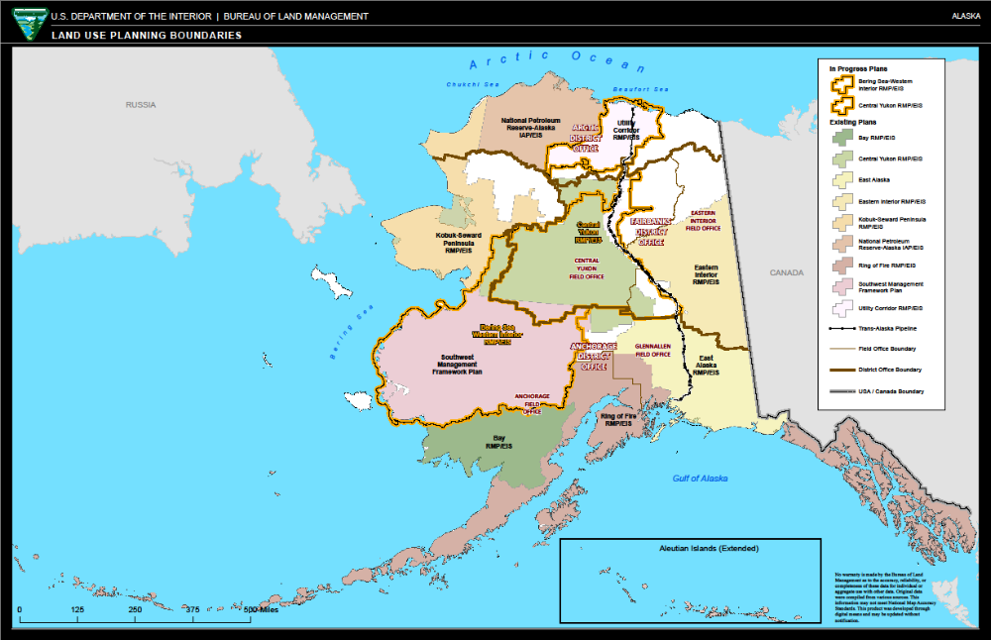

Appendix F: Figures
Figure 1: Picture of Dalton Highway from BLM Alaska State Office
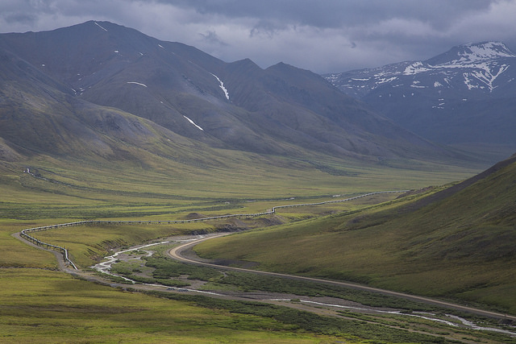

Appendix G: Tables (over one page)
Table F-1: List of non-native and invasive species
Scientific name | Common name

Table F-2: List of TES Species
Scientific name | Common name

Appendix H: Additional Appendix as needed

This list should include all individuals involved in the preparation of the EA document, including BLM, Cooperating Agency staff and contractors (as applicable).

